The following is to ensure school-level parent and family engagement plans meet the requirements of Section 1116(b) of the Elementary and Secondary Education Act (ESEA), as amended by the Every Student Succeeds Act (ESSA)
Assurances
The above named school agrees to the following assurances:
- Involve parents of children served in Title I, Part A in decisions about how Title I Part A funds are spent;
- Carry out the programs, activities, and procedures in accordance with the definitions in Section 8101 of ESEA;
- Jointly develop/revise plan with parent and make available to the local community;
- Involve parents and families in planning, reviewing, and improving schoolwide program plan;
- Use the findings of parent and family engagement plan review to design strategies for more effective engagement, and to review, if necessary, the school’s parent and family engagement plan;
- Provide each family with timely notice information regarding their right to request information on the professional qualifications of the student’s classroom teachers and paraprofessionals;
- Notify each family, in a timely manner, when their child has been assigned, or has been taught for four or more consecutive weeks, by a teacher(s) who is out of field;
- Provide each family with an individualized student report about the performance of their child(ren) on the State assessments [ESEA Section 1116]
Mission Statement
1. Does the mission statement include:  How the parent and family engagement plan is a shared responsibility?  How the parent and family engagement plan will assist in providing high quality instruction for all learners? | Winegard Elementary is committed to developing successful students who are equipped with 21st century skills. The staff believes that the involvement of parents and community members is essential to student achievement. We, therefore, commit to involve all stakeholders in our students' education and encourage participation in all school activities. Winegard commits to inviting all parents to join the School Advisory Council where they will be able to review, plan, and improve on school programs. The Parent Engagement Liaison will work collaboratively with community members to provide high interest, high quality workshops so that parents can support education at home for all learners. We will host multiple curriculum nights aligned to grade level standards to demonstrate effective instructional strategies as a bridge between home and school.

Involvement of Parents
2. Does the plan include:  How the school will involve the parents and families in an organized, ongoing, and timely manner in the planning, review and improvement of Title I programs, including involvement in decision making of how funds for Title I will be used [ESEA Section 1116]? | Winegard Elementary will inform parents, and invite their active partnership in the education of their child in an organized, ongoing, timely manner. We will utilize a variety of methods to assure all parents receive open communication in the manner they are available to receive it. Examples include:  *School to home communication in English and other languages  *School Website  *ClassDojo  *Student Agendas  *School Marquee Posts  *Connect Orange Messages  *Emails  *Texts/ Talking Points  *And other best known practices as needed  We believe that parents should be involved in all aspects of Title 1 programs and all meetings, including the Parental Involvement Plan discussion meeting. Winegard Elementary encourages parents to attend and participate in meetings. The Title 1 Committee will work in conjunction with the School Advisory Council to review, plan, and improve school programs. The principal and the Title 1 contacts will provide agendas and reminders of meetings (via Connect-Ed messages, flyers, and weekly Dojo/ email newsletters) to encourage participation. During the annual Title 1 meeting, parents will be educated on the purpose and requirements of being a Title 1 school and the parental involvement budget. Parents, teachers, and staff shall provide input for using these funds. Parents will be notified of Title 1 programs through the school website, flyers, meeting agendas, Connect-Ed messages, and weekly Talking Points/ monthly calendars and PowerPoint slides in the front office. Curriculum family nights (by grade level), faculty meetings, PTA meetings, and SAC meetings will also have time allocated for an update on the PAFEP. Minutes will be kept for all meetings held, as well as sign in sheets for attendance. A meeting will be held in the spring of each year to review the Title 1 Parental Involvement Plan, Title 1 budget, School Improvement plan, and Student/Teacher/Parent compact. The annual Title 1 Parent feedback survey will also gather parental involvement input.

Coordination and Integration with Other Federal Programs
3. Does the plan include:  How the school will coordinate and integrate parent and family engagement programs and activities?  How the school will coordinate and integrate parent and family activities that teach parents how to help their child(ren) at home [ESEA Section 1116]? | Winegard Elementary will coordinate and integrate parent engagement  programs and activities through our Parent Engagement Liaison. Our Family and Community Engagement Committee will plan and implement a  variety of linked to learning programs and events to train parents on how to help their children at home. The Parent Engagement Liaison will work collaboratively with community members to provide high interest, high quality workshops so parents can support education at home for all learners. We will host multiple curriculum nights aligned to grade level standards to demonstrate effective instructional strategies as a bridge between home and school.
Program | Coordination
Pre-K Varying  Exceptionalities ESE  - IDEA | The school will collaborate with the Title 1 office and district level office to  coordinate transition for students entering regular kindergarten and other VE,ESE, and IDEA programs. Supplemental instructional support provided by Title I will be discussed with parents during the development of the students IEP.  The school will hold meetings with parents, VPK teachers, and Kindergarten  teachers to discuss the needs of the students and the skills that will be needed in kindergarten. The VPK teacher will coordinate with the kindergarten teachers to transition the VPK students by visiting the kindergarten classrooms in the spring.
Title I | Title I funds are used to support the core curriculum, staff development,  tutoring, and supplies for parent involvement (SAC meetings and monthly  Family Nights). The Principal and Title I Contact will Coordinate with the Title I office for these events
Title II | Title II funds support professional development needs of the staff as it related to Parental Involvement, Professional Learning Communities and Staff Development. Staff training will be held at least four times to train the teachers in effectively using parental involvement modules. The information gained from these trainings will be shared with parents in SAC meetings and parent teacher conferences to keep parents informed about Florida Standards
Title Ill
Title X | McKinney Vento Program provides support to our homeless students.

Annual Parent Meeting
4. Does the plan include:  A description of the specific steps the school will take to conduct the annual meeting to inform parents and families of participating children about the school’s  Title I program?  A description of the nature of the Title I Program that is shared with parents (schoolwide or targeted assistance)?  A description of how the meeting will cover adequate yearly progress (AYP), school choice, and the rights of parents are covered at the annual meeting? | Winegard Elementary will present an annual Title I Meeting to families and  community members so that all stakeholders are well informed and united in vision regarding the Title I Program at our school. A well-organized program planned with specific steps will be utilized to assure a thorough information session is provided. This will include the following: Participants will sign in and be provided with an agenda. They will view a guided power point presentation with our Title I Compliance representative. The information contained in the presentation will inform and educate participants about How Title I schools are designated, how they receive funding and how that funding is used to support learning. Parental rights, information on Adequate Yearly Progress, school choice and resource information is provided as well as the school compact.  Parents are given the opportunity to ask questions. Translation is provided  throughout the meeting.  Parents and community member stakeholders are informed of the mission of the Title I Program by the following statement as shared in the power point: Title I schools receive services from the largest federal aid to education program in existence.  Title I has been in existence since 1965 and continues to level the academic playing in field for children victimized by poverty Title I provides services and educational programs to help students achieve. Title I Immigrant Programs administer in excess of 500 million in federal funds to school districts and agencies in Florida for high quality supplemental instruction  and support services for educationally disadvantaged children. Our mission is to provide leadership and technical assistance to local education agencies and local operating agencies to implement programs and services that ensure that all children obtain a high-quality education and reach, at a minimum, proficiency on challenging state academic achievement standards and state academic assessments, We provide service to local school districts, agencies, private schools, and local Homeless Programs.  Please refer to the outline below that details the specific steps Winegard  Elementary will implement to conduct the Title I Annual Meeting.
Activity/ Task | Person Responsible | Timeline | Evidence of Effectiveness
Notices sent home  to parents in English  and/or other  languages | Title I Coordinator, PEL | Sept. 2023 | Copy of notice
Title I Annual  Meeting date posted  on the school  Marquee | School Administrators | Sept. 2023 | Picture of marquee/ Talking Points and School Calendar
Title I Meeting  advertised in the  Patriot Press school  Newsletter/ Class Dojo | Title I Coordinator, Sept. 2021 Copy of newsletter  School Administrators,  PEL | Sept. 2023 | Copy of newsletter/ Dojo Snip/ Talking Points snip
Reminder offered  via Connect Ed | School Administrators | Sept. 2023 | Copy of message
Title I Meeting  agenda and  presentation  materials, and sign  in sheets developed | Title I Coordinator, PEL | Sept. 2023 | Copy of agenda, power  point intro page, copy of sign in sheet
Title I Meeting  Conduction | Title I Coordinator, PEL, and Translator | Sept. 2023 | Copy of agenda, handouts, pictures, and sign in sheets
Title I Compliance  documentation  maintained | Title I Coordinator, PEL | Sept. 2023 | Copies of documentation

Flexible Parent Meetings
5. Does the plan include:  How will the school offer a flexible number of meetings, such as meeting in the morning or evening?  How will the school provide, with Title I funds, transportation, child care or home visits, as such services relate to parent and family engagement [ESEA Section 1116]? | Winegard Elementary recognizes that our parents have diverse work/home  schedules as evidenced in recent parent surveys. Many of our events are  planned at various times so that all parents have the opportunity to attend.  During the first and third semester of school, parent conferences are scheduled to discuss students' progress. Winegard has designated certain days for parent conferences. Conferences will be scheduled in the afternoon from 2:45pm to 6:45 pm. If a parent is unable to attend, teachers will work with parents to accommodate work/home schedules. Conferences may be scheduled in the morning, afternoon, evening, or during teacher planning time. Phone conferences are another option that parents may choose. Winegard also hosts grade level presentation evenings frequently on campus. Translators will be offered at all events where families are invited, including conferences, family events, and other meetings (as needed). Free Parent English classes are offered once a week in the am and the pm at our Oak Ridge NCF location. Parent Life Skills Workshops are also offered in the mornings, to allow those who cannot attend evening trainings and events the opportunity to obtain the same skill building offered in the evenings. Weekend parent related meetings and workshops are also offered for those with busy weekday schedules. We will provide bus transportation to a district provided Parent Academy. We will also offer off campus PTA meetings and family events for those who not comfortable with on campus activities.

Building Capacity
6. Does the plan include:  How the school will implement activities that will build the capacity for meaningful parent/family involvement?  How will the school implement activities that will build relationships with the community to improve student achievement?  How the school will provide material and training to assist parents/families to work with their child(ren)?  How the school will provide other reasonable support for parent/family engagement activities [ESEA Section 1116]? | Winegard Elementary is a family friendly school! We welcome and embrace  every opportunity to build and enrich the capacity of all our stakeholders. Our Parent Engagement Liaison assures enrolling families receive personalized orientation, maintains current information regarding school and community family events, provides free English classes and parent workshops, and sponsors at least one Parent Academy event and at least one virtual Parent Academy event. The PEL also provides and maintains a family resource center for parents to visit and receive needed materials to support education as well as free community resources and services. The heart of our school is the positive relationships we have with our families and community members. Together we have done great things and commit to challenge ourselves to go above and beyond expectations. We have established our first Family Resource Center. Community members and Partners in Education have been extremely generous in donating nearly all the resources and materials we have for families at no cost. These items include clothing, food, school supplies, tutoring, volunteers, counselors, job training and preparation, student incentives, rewards and on-site training’s. In return, our families have shown their gratitude by creating thank you notes, posters, letters, and have even created file folder games they can check out. The Family Resource Center has quickly become a buzzing hub of parent workshops, community meetings, socials, and resources to boost academic success. The Orlando Public Library also provides literacy workshops to model effective shared reading strategies for families Essendant and Taft NCF also provide much needed resources for our families so that they can provide positive support for their children at home. Indeed, it takes a village to raise a child. Our families have the assurance that if they reach out to our Parent Engagement Liaison or visit to our Family Resource Center, the will receive what is needed for their family.
Activity/ Task | Person Responsible | Correlation to Student Achievement | Timeline | Evidence of Effectiveness
Meet the Teacher | Administration,  Teachers, PEL | A positive rapport is  established,  classroom and  campus policies and  procedure are  introduced | Aug. 2023 | flyers,  newsletter,  marquee,  Connect Orange;  Pictures, Talking Points
Open House and Title I Meeting | Administration, Title I Coordinator, Teachers, PEL | Focus on student performance and achievement, sustained engagement | Sept 2023 | flyers, newsletter,  school marquee,  sign in sheets,  Connect Orange, Facebook, school website, Class Dojo, Talking Points, agenda, minutes,  pictures, compacts
School Advisory, PTA, and PLC Meetings | Administration, PEL, Teachers, Community Members | Intense focus on  achievement,  sustained family and community  engagement and  partnership in  decision making | Monthly | flyers, agenda, minutes, pictures, sign in sheets, Canvas, Class Dojo, school website, Connect Orange, Facebook, Talking Points
Parent Workshops | PEL | Intense focus on  literacy support at,  home for ELL  Families | Monthly | flyers, agenda, minutes, pictures, sign in sheets, Canvas, Class Dojo, Talking Points, Connect Orange, Facebook
Report Card Conference Nights | Classroom Teachers | Teachers will conduct individual conferences to discuss student progress toward benchmarks and share individual needs. | Sept/Oct. 2023 Jan. 2024 | flyers, newsletter,  school marquee,  sign in sheets,  Connect Orange, Canvas, Class Dojo, Talking Points, school compact follow ups,
Family Curriculum Nights | Instructional Staff | Parents will interact with instructional staff and their children while learning a target new skill | FALL  Oct/Nov.2023  Spring  Jan/Feb/April 2024 | flyers, newsletter,  school marquee,  sign in sheets,  Connect Orange, Canvas, Class Dojo, Talking Points, Facebook, handouts, pictures
Newsletter, Flyers,  Marquee, Website, Connect  Orange, Class Dojo, Remind, Canvas, Facebook | Administration | Parents and students will have current access to school related events and activities | Ongoing | Sample copies of newsletter
Multicultural Family Night | Administration, Teachers, Parent Representatives, Community Members | School personnel, families and community members will unite to celebrate diversity, understanding, and tolerance. | May 2024 | Copies, of newsletter, flyers, marquee, Connect Orange, Facebook, Class Dojo, Talking Points, Canvas, school website, handouts, surveys

Staff Development
7. Does the plan include:  A description of the professional development activities the school will provide to educate the teachers, specialized instructional support personnel, principals, other school leaders and other staff:  - with the assistance of parents/families, in the value and utility of contributions of parents/families?  - in how to reach out to, communicate with, and work with parents/families as equal partners?  - in implementing and coordinating parent/family programs, and in building ties between parents/families and the school [ESEA Section 1116]? | Winegard Elementary is dedicated to building the capacity of all our faculty and staff. We provide a variety of onsite professional development activities to educate our leadership team, teachers, specialized support personnel,  paraprofessionals, and other team members. All personnel are encouraged to attend district training specific to their position as well.  In addition to academic training, all personnel receive Title I training to build capacity in parent and family engagement. As a Title I school, it is vital that we are all united in our support for student academic success. The contributions of parents and families as education partners is vital in assuring every possible resource has been provided for students at school and at home. We are all in this together in training today's youth to be tomorrow's confident, competent leaders.  Below is a detailed outline of the four Title I training modules we use throughout the year to train all of our faculty and staff in making that positive connection between home and school.
Activity/ Task | Person Responsible | Correlation to Student Achievement | Timeline | Evidence of Effectiveness
Parent and Family  Engagement  Professional  Development  Module 1 | CRT | Improved staff resources to create a welcoming school environment, understand the value and importance of parent and family engagement, and maintain strong school to home relationships | Feb 2024 | Canvas
Parent and Family  Engagement  Professional  Development  Module 2 | CRT | Improved ability of staff to work with parents and families | April. 2024 | Canvas

Other Activities
8. Does the plan include:  How other activities, such as the parent resource center, the school will conduct to encourage and support parents and families in more meaningful engagement in the education of their child(ren) [ESEA Section 1116]? | Winegard Elementary is fortunate to have a generous supply of time, talent,  and resources to support our parents, families, and students with their needs. The following are some of the resources we provide to support families in their desire to have more personal, meaningful engagement in the education of their child:  • Family Resource Center  • Food Pantry  • Exceptional Student Services  • Behavioral Support Services  • Parent Workshops  • District Parent Academy and Virtual Academy events throughout the  Year  Below are specific activities designed to promote and support parents and  families in more personal, meaningful engagement in the education of their  children
Activity/ Task | Person Responsible | Timeline | Evidence of Effectiveness
Family Resource Center | PEL | Ongoing | flyers, sign in sheets, surveys
Food Pantry | PEL | Ongoing | Pantry Log
Exceptional Student Services | Staffing Specialist/MTSS | Ongoing | Data
Behavior Support Services | Dean | Ongoing | Data
Parent Workshops | PEL | Ongoing | flyers, sign in sheets, surveys
District Parent Academy, Lunch and Learns, Mini Academies | PEL | Ongoing ( PEL hosts access to at least one of the events per year) | flyers, sign in sheets, surveys

Communication
9. Does the plan include:  How will the school provide timely information about the Title I programs?  How the school will describe and explain the curriculum at the school, the forms of assessment used to measure student progress and the achievement levels students are expected to obtain?  How, if requested by parents, the school provides opportunities for regular meetings to formulate suggestions and to participate, as appropriate, in decisions relating to the education of their child(ren)/  How will the school submit parents/ families comments if the schoolwide plan is not satisfactory to them [ESEA Section 1116]? | Winegard Elementary will maintain timely communication in multiple languages about Title I programs through the following methods:  - Hosting an annual title I parent Meeting  - Conducting one on one New Parent Orientation for parents new to the school to orientate parents to school resources and the Title I Program. A Welcome to Winegard take home pack will also be provided for further home reference. Administration and other faculty members will support parents' understanding of Title I information via translation as needed. Parents will be educated on the curriculum, policies, and procedures as well as assessments and be shown how those assessments measure progress and indicate expected progress. Parents are informed about Title I programs to support students and families. Several communication techniques used to convey information about Title I programs include:  • School Compact  • Report Card Nights  • Progress Book  • Student Planners  • Regularly scheduled SAC/PTA meetings  • Parent Conferences  • Newsletters/Monthly Calendars/ Connect Orange Messages/Marquee/Talking Points  Winegard Elementary provided monthly SAC meetings. Meetings are advertised school wide via newsletter, flyers, the school marquee, and Connect Orange. PTA meetings are also held at least quarterly with the same advertisement to encourage parent participation. We value the input of our parents in decision making related to the education of their children. The perspective of our parents is valuable in helping administration learn the needs of our students and families from a personal dialogue. Parents are also invited and encouraged to provide suggestions at conferences, in surveys, and through our Parent Comment Box located in the main office. The school will submit parents/families comments if the school wide plan is not satisfactory to them at the next SAC meeting to collaborate for review, revision and resolution.

Accessibility
10. Does the plan include:  A description of how the school will provide full opportunities for participation in parent/family engagement activities for all parents/families?  A description of how the school will share information related to school and parent /family programs, meetings, school reports, and other activities in an understandable, uniform format, and in languages that the parents/families can understand? | Winegard Elementary will provide full opportunities for participation in parent family engagement activities for all parents and families by providing multiple opportunities for access by:  • Providing translation in written information, Connect Orange messages, conferences, meetings, and events for ELL families.  • Offering multiple times during mornings, afternoons, and evenings as well as alternating days for parents and families to participate.  We will share information related to school/family programs, meetings, school reports, and other activities in an understandable uniform format and in languages parents can understand. The methods used will be:  • School Newsletter  • School Website  • Student Planners  • Emails  • Texts/Talking Points  • And other know best practices as needed

Discretionary Activities
11. Does the plan include:  Any activities that are not required, but will be paid for through Title I, Part A funding (for example: home visits, transportation for meetings, activities related to parent/family engagement, etc.) | Winegard Elementary explores every opportunity to provide the maximum support for our students and their families. Title I, Part A funding provides for additional activities to support student achievement. These activities are supplemental to those that are required.
Activity/ Task | Person Responsible | Correlation to Student Achievement | Timeline | Evidence of Effectiveness
Parent Training Workshop | Administration  PEL | Increase the engagement of parents and their knowledge of student achievement expectations. Provide parents with the skills and tools necessary to provide effective academic support at home. | Ongoing | Sign in sheets  Surveys  pictures
Parent Academy Transportation | Administration  PEL | Increase the engagement of parents and their knowledge of various methods to disconnect from technology and reconnect with their children. | Spring 2024 | Sign in sheets  Surveys  Pictures

Barriers
12. Does the plan include:  A description of the barriers that hindered participation by parents during the previous school year?  A description of the steps the school will take during the upcoming school year to overcome the barriers (with particular attention paid to parents/families who are disabled, have limited English proficiency, and parents/families of migratory children [ESEA Section 1116]? | Winegard Elementary has identified barriers our families experience related to being engaged in their child's education and/or at home. We reviewed the prior year's Parent and Family Engagement Plan (known as the PIP at that time), and noted feedback from parents and families at SAC and PTA meetings as well as surveys and the Parent Comment Box. The following barriers to parent and family engagement expressed and recorded are:  • Language  • Education  • Homelessness  • Lack of current phone numbers  • Child Care  • Time  Below are the specific methods we will use to address the barriers that existed in the previous year. We will continue to address any additional barriers as they are resented.
Barriers (Including the Specific Subgroup) |  | Steps the School will Take to Overcome
Parents do not speak the language(ELL) |  | Make Connect ED calls and Talking Points text to all parents in English and Spanish for events and meetings. Provide translators at events and meetings .Provide written information in multiple languages. Provide English classes for parents.
Parents lack of literacy skills (ELL and Free / Reduced Lunch |  | Provide literacy training and support and referrals to local community trainings as well.
Homeless and/or trouble getting to events (Economically disadvantaged, ELL, White, Asian, Hispanic and African American |  | Provide Transportation support if needed.
Lack of current phone numbers (Free/Reduced)  Lunch, White, Asian, Hispanic and African |  | Send home requests for updated phone numbers twice a year. Send home meeting and event information via flyers. Put information on the marquee and tell parents personally when they come on campus to pick up students.
Single parents with no childcare options (Free/Reduced Lunch, White, Asian, Hispanic and African ) |  | Make all events and meetings family friendly so parents can bring the younger children with them. Provide childcare, if needed.
Lack of parent attendance due to schedule challenges (Economically disadvantaged). |  | Provide different times for meetings, training, and events.

School-Parent Compact
13. Does the plan include:  As a component of the school-level parental involvement policy/plan, each school shall jointly develop, with parents for all children served under this part, a school-parent compact that outlines how parents, the entire school staff, and students will share the responsibility for improved student academic achievement? | Provide a scanned copy with this document of the School-Parent Compact and evidence of parent input in the development of the compact.  *Primary Grade Compacts  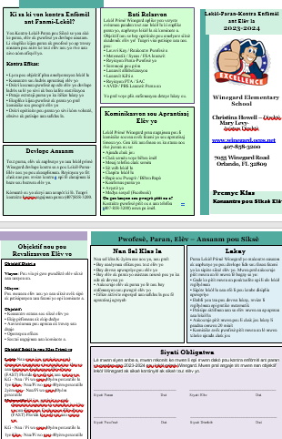  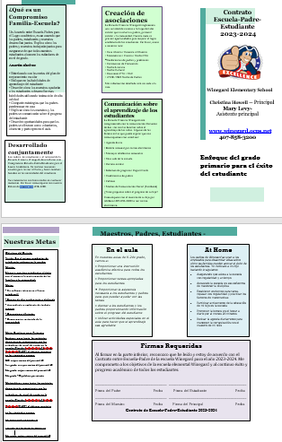  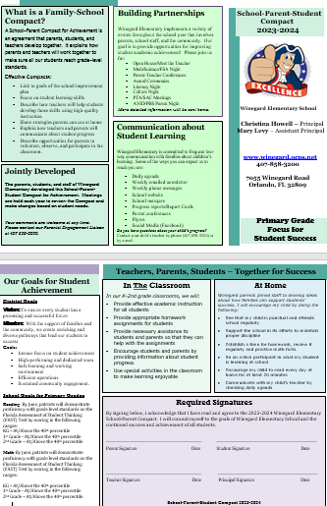  English Spanish Creole  *Intermediate Grade Compacts  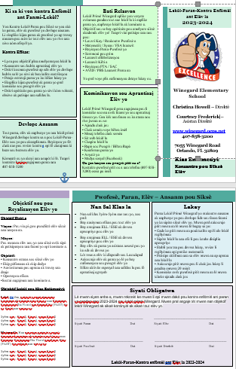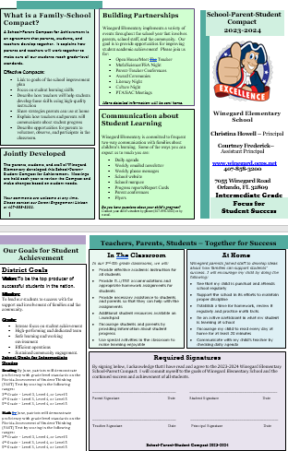 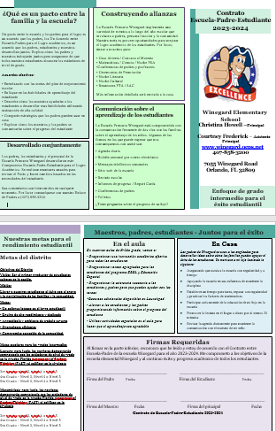 Creole Spanish English

Adoption
The parental involvement policy/plan has been developed jointly with, and agreed on with, parents of children participating in Title I, Part A programs, as evidence by
This policy/plan was adopted by the school on and will be in effect for the period of .
The School will distribute this policy to all parents of participating Title I, Part A children on or before.

Signature of Authorized Personnel
Date

Provide evidence that this policy/plan has been developed with the input from parents based on the review of the previous school years Parent and Family Engagement Plan if applicable.
The following documents can be submitted as evidence:
- Parent survey of previous year’s events and activities
- Any SAC and PTA artifacts where Title I/PFE topics were on the agenda
- Parent Feedback Summary of PFEP Evaluation
- Parent and Family Engagement Activities Tracking Form

